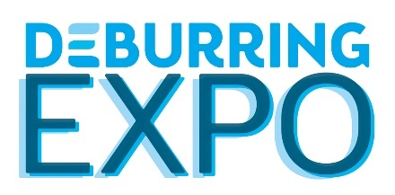
Press Release 7 – Final Report

5th Leading Trade Fair for Deburring Technology and Precision Surface Finishing Held Successfully in Karlsruhe
DeburringEXPO 2023 Distinguished by Outstanding Quality

Neuffen, 17 October 2023: Nearly all of the more than 1200 expert visitors arrived at this year’s DeburringEXPO in Karlsruhe with specific tasks and strong demand for information from the 10th through the 12th of October. For the majority of the 107 exhibiting companies from 13 countries, this resulted in excellent contacts and new projects with good prospects for post-event business. With more than 500 participants, the bilingual expert forum also lived up to its reputation as a coveted source of knowledge.

Deburring and the production of precision surface finishes are just one aspect of surface treatment technology. But due to quality and cost considerations, manufacturing companies are focusing on them to an ever greater extent. This is confirmed impressively by the current challenges and projects brought along to this year’s DeburringEXPO by the 1214 visitors (roughly 10 % more than in 2021) from the 10th through the 12th of October. 20% of the event’s visitors came from outside of Germany and 18 countries were represented. The largest percentage of visitors came from Germany, followed by Switzerland, Italy, Austria and Slovenia. “The fact that participation at the trade fair paid off for the exhibiting companies is more important than the figures themselves,” notes Hartmut Herdin, managing director of private trade fair promoters fairXperts GmbH & Co. KG.

Significant Contacts Promise Good Post-Event Business
And this appears to be the case, as is evident from the following comments from Steffen Hedrich, managing director of Kempf GmbH: “Practically every visitor at DeburringEXPO comes to the trade fair with an ongoing problem for which they require a solution. As a result, discussions go into great depth very quickly. We also presented a world’s first for deburring tasks which place stringent demands on chamfer quality, and it generated significantly better feedback than I expected beforehand. For us it’s already clear that we’ll exhibit again in 2025.” The fact that there was so much tangible action at DeburringEXPO was due to the very high proportion of expert visitors. The most prominently represented sectors include machinery and systems manufacturing, metalworking and metal processing, medical and pharmaceuticals technology, tool and mould making, precision engineering and optics, the automotive industry, as well as aviation and aerospace technology. Roughly 92% of all visitors are involved in company investment decisions. The quality of the contacts and RFQs is correspondingly good, which were fielded at the event by a majority of the 107 exhibitors from 13 countries. “We took over the business from another company that exhibited at the trade fair on a regular basis and were thus also on hand this year. We were surprised by the highly specific tasks and RFQs, and by the resulting quality of our leads. I think we’ll exhibit again at the next DeburringEXPO,” reports Shigeru Kajisaki, managing director of Yamazen Europe GmbH. Dieter Münz, managing director of Ultratec Innovation GmbH, is also very satisfied with the way things went at the trade fair: “DeburringEXPO is our most important trade fair. You don’t have as many visitors as you do at the big metalworking events, but they all come with a specific task in mind. As a result, the success rate for good post-event business is significantly higher here than at other trade fairs. This is why we will definitely be back in 2025.” David Bartels, laboratory manager responsible for process engineering sales at Höckh Metall-Reinigungsanlagen GmbH, who exhibited together with SGM s.r.l. (manufacturer of thermal deburring systems), also drew a positive balance: “Deburring is one of the major topics at DeburringEXPO, and cleaning is an upstream or downstream production step. The joint trade fair presentation with SGM has resulted in synergies that have enabled us to generate more interesting leads than at previous events, including numerous new contacts.” Patrick Taschek, sales and project engineer at Rösler Oberflächentechnik GmbH, recalls very detailed discussions and RFQs: “During the three days at the trade fair, we were visited by existing customers with whom we were able to discuss new projects. On the other hand, we were also able to establish good new contacts. Our meetings frequently focused on reducing the number of manual processes, as well as simplifying and automating processing operations.” Jan-Niklas Merkel from the technical sales department at SHL AG also discovered that the trend towards more automation, which is not least of all due to the shortage of qualified personnel, was a dominant theme at this year’s DeburringEXPO: “The visitors came from various metalworking sectors with different tasks for deburring and the production of precision surface finishes. We observed that the requirements for automation solutions are becoming more demanding and that greater degrees of automation are required.”

High Levels of Visitor Satisfaction Thanks to Numerous Innovations
The fact that the leading trade fair for deburring technologies and precision surface finishing lived up to the expectations of the visitors as well is made apparent by the evaluation of the visitor survey. Roughly 95% were satisfied or very satisfied with the trade fair offerings. Without a doubt, the numerous new and further developments presented by the exhibitors contributed to the high levels of satisfaction. Further evidence of visitor satisfaction is the recommendation rate: more than 75% would recommend a visit to the leading trade fair as an information and procurement platform to colleagues and business partners.

Coveted Source of Knowledge
Right from its very first edition, the bilingual expert forum at DeburringEXPO has established itself as a coveted source of knowledge. 505 participants took advantage of the simultaneously interpreted presentations (German <> English) at this year’s event in order to deepen their knowledge of deburring technologies and the production of precision surface finishes. For more than 30% of the visitors, the programme schedule for the expert forum was the decisive factor for selecting the day on which they visited the trade fair.
The next DeburringEXPO will be held at the Karlsruhe Exhibition Centre from the 14th through the 16th of October, 2025.
www.deburring-expo.de

Captions
Photo: DBE_2023_2
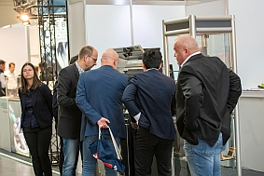
Numerous exhibitors from all exhibition segments presented new and further developments, which met with great interest amongst the visitors. The opportunity of experiencing them live and discussing possible applications for individual tasks generated considerable enthusiasm.

Photo: DBE_2023_5
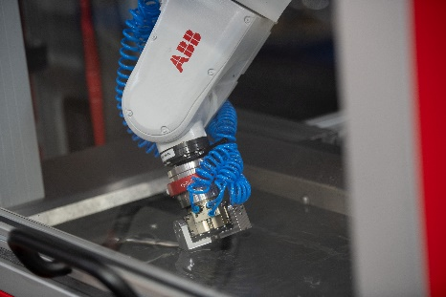
The automation of deburring and surface finishing processes was one of the dominating topics at this year’s DeburringEXPO. The exhibitors presented a variety of alternatives to this end.

Photo: DBE 2023_FF_1
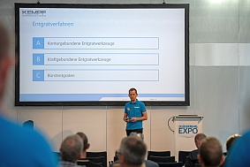
The bilingual expert forum with a total of 23 simultaneously interpreted presentations (German <> English) attracted more than 500 participants who sought new knowledge and expanded their know-how.
Image source: fairXperts GmbH & Co. KG

- - -
Thank you in advance for sending us a specimen copy or links to online publications.

Contact persons for the editors, and for requesting image files:
SCHULZ. PRESSE. TEXT., Doris Schulz, Journalist (DJV), Landhausstr. 12,
770825 Korntal, Germany, phone: +49 (0)711 854085, ds@pressetextschulz.de, www.schulzpressetext.de

fairXperts GmbH & Co. KG, Hartmut Herdin, Hauptstr. 7, 72639 Neuffen,
Germany, phone: +49 (0)7025 8434-0, info@fairxperts.de, www.fairxperts.de

